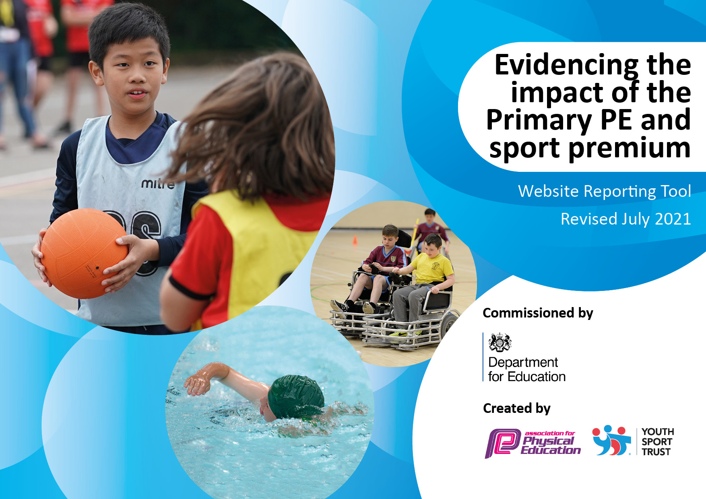
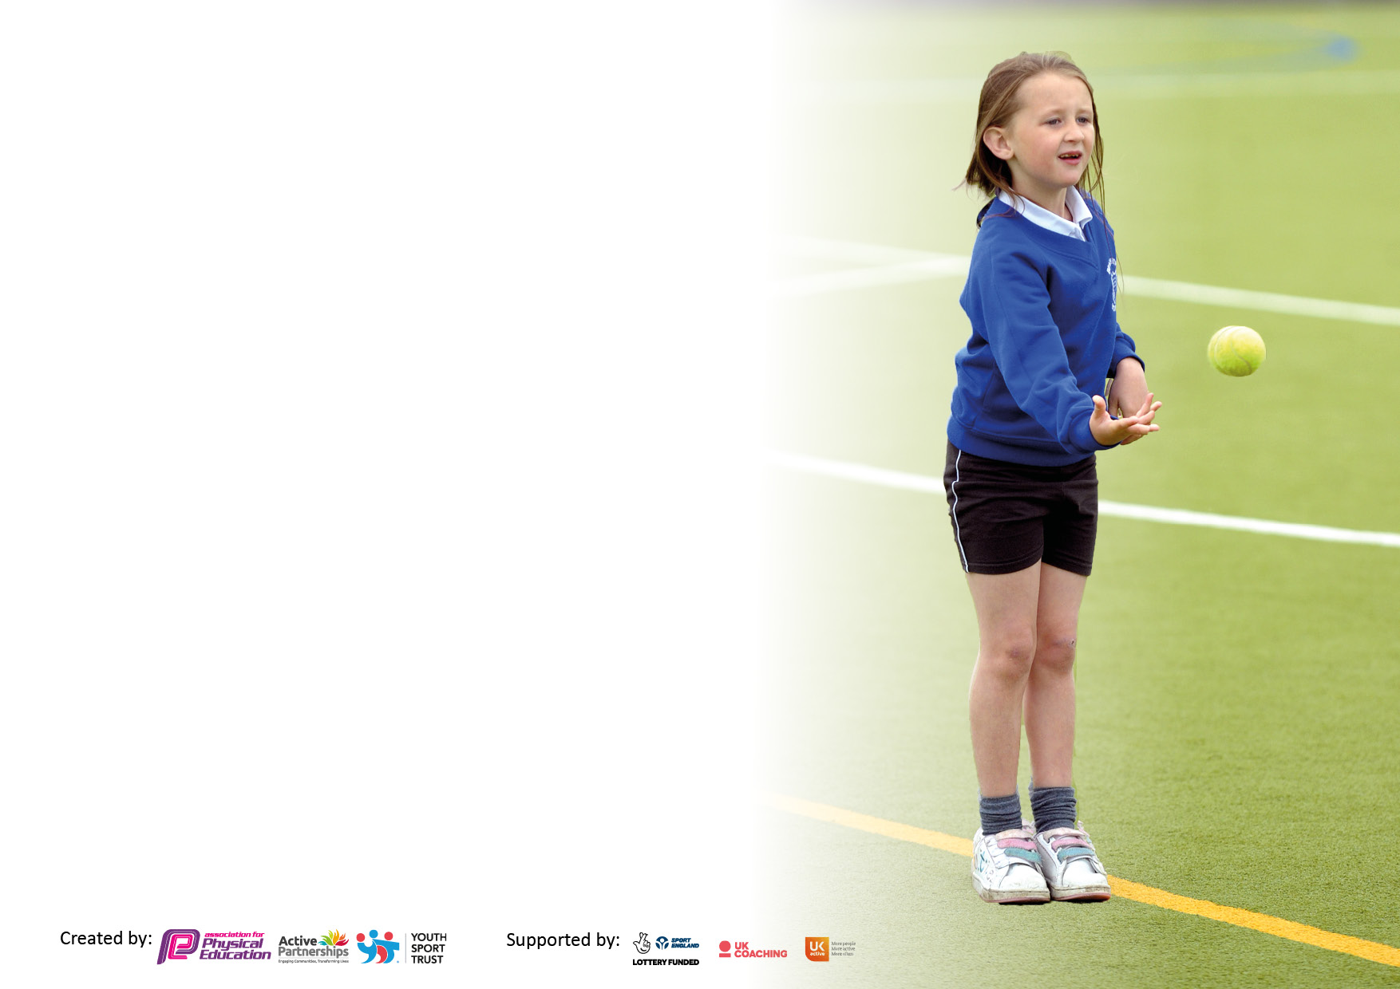

It is important that your grant is used effectively and based on school need. The Education Inspection Framework makes clear there will be a focus on ‘whether leaders and those responsible for governors all understand their respective roles and perform these in a way that enhances the effectiveness of the school’.

Under the Quality of Education Ofsted inspectors consider:
Intent - Curriculum design, coverage and appropriateness
Implementation - Curriculum delivery, Teaching (pedagogy) and Assessment
Impact - Attainment and progress

To assist schools with common transferable language this template has been developed to utilise the same three headings which should make your plans easily transferable between working documents.

Schools must use the funding to make additional and sustainable improvements to the quality of Physical Education, School Sport and Physical Activity (PESSPA) they offer. This means that you should use the Primary PE and sport premium to:

- Develop or add to the PESSPA activities that your school already offer
- Build capacity and capability within the school to ensure that improvements made now will benefit pupils joining the school in future years
- The Primary PE and sport premium should not be used to fund capital spend projects; the school’s budget should fund these.

Pleasevisitgov.ukfortherevisedDfEguidanceincludingthe5keyindicatorsacrosswhichschoolsshoulddemonstrate animprovement.Thisdocumentwillhelpyoutoreviewyourprovisionandtoreportyourspend.DfEencouragesschools to use this template as an effective way of meeting the reporting requirements of the Primary PE and sport premium.

We recommend you start by reflecting on the impact of current provision and reviewing the previous spend.

Schools are required to publish details of how they spend this funding, including any under-spend from 2019/2020, as well as on the impact it has on pupils’ PE and sport participation and attainment. All funding must be spent by 31st July 2022.

We recommend regularly updating the table and publishing it on your website throughout the year. This evidences your ongoing self-evaluation of how you are using the funding to secure maximum, sustainable impact. Final copy must be posted on your website by the end of the academic year and no later than the 31st July 2021. To see an example of how to complete the table please click HERE.
Created by: Supported by:

Details with regard to funding
Please complete the table below.

Total amount carried over from 2019/20 | £5,900
Total amount allocated for 2020/21 (£18, 102.00 + £2, 246.23) | £16,000
How much (if any) do you intend to carry over from this total fund into 2021/22? | £8367.000
Total amount allocated for 2021/22 | £14, 000
Total amount of funding for 2021/22. To be spent and reported on by 31st July 2022. | £22, 367.000
Swimming Data
Please report on your Swimming Data below.

Meeting national curriculum requirements for swimming and water safety.

N.B. Complete this section to your best ability. For example you might have practised safe self-rescue techniques on dry land which you can then transfer to the pool when school swimming restarts.
Due to exceptional circumstances priority should be given to ensuring that pupils can perform safe self rescue even if they do not fully meet the first two requirements of the NC programme of study
What percentage of your current Year 6 cohort swim competently, confidently and proficiently over a distance of at least 25 metres?  N.B. Even though your pupils may swim in another year please report on their attainment on leaving primary school at the end of the summer term 2020.  Please see note above | 32%
What percentage of your current Year 6 cohort use a range of strokes effectively [for example, front crawl, backstroke and breaststroke]?  Please see note above | 32%
What percentage of your current Year 6 cohort perform safe self-rescue in different water-based situations? | 18%
Schools can choose to use the Primary PE and sport premium to provide additional provision for swimming but this must be for activity over and above the national curriculum requirements. Have you used it in this way? | No

Action Plan and Budget Tracking
Capture your intended annual spend against the 5 key indicators. Clarify the success criteria and evidence of impact that you intend to measure to evaluate for pupils today and for the future.

Academic Year: 2021/22 | Total fund allocated: | Date Updated:
Key indicator 1: The engagement of all pupils in regular physical activity – Chief Medical Officers guidelines recommend that primary school pupils undertake at least 30 minutes of physical activity a day in school |  |  |  | Percentage of total allocation:
 |  |  |  | 35.13%
Intent | Implementation |  | Impact
Your school focus should be clear what you want the pupils to know and be able to do and about  what they need to learn and to  consolidate through practice: | Make sure your actions to achieve are linked to your intentions: | Funding allocated: | Evidence of impact: what do pupils now know and what can they now do? What has changed?: | Sustainability and suggested next steps:
Children have opportunities to engage in after-school sport and lunch time clubs to further develop key skills and achieve the recommendation.  Sport’s coaches and staff leading games during lunchtimes to support engagement in regular physical activity.  To introduce sports leaders who set up playground activities/ physical challenges for children to regularly. | A sports coach continued to lead physical activities during lunchtimes and aimed to increase participation.  Children complete the Daily mile to encourage being active and to improve fitness levels. | £6,439.42 | All pupils had opportunities to attend extra-curricular sports clubs across the academic year.  Football club at lunch time and after school was well attended throughout the academic year by different year groups. | To continue to re-establish a full programme of extra-curricular sporting opportunities, offering a wider range.  To continue to run and develop sports leaders for KS1.  To re- introduce extra activities ran by staff alongside coaches.
Key indicator 2: The profile of PESSPA being raised across the school as a tool for whole school improvement |  |  |  | Percentage of total allocation:
 |  |  |  | 47.37%
Intent | Implementation |  | Impact
Your school focus should be clear what you want the pupils to know and be able to do and about  what they need to learn and to  consolidate through practice: | Make sure your actions to achieve are linked to your intentions: | Funding allocated: | Evidence of impact: what do pupils now know and what can they now do? What has changed?: | Sustainability and suggested next steps:
To ensure that PE equipment is maintained and used effectively across the school.  To aim to improve children’s mental health and wellbeing across school to help support them in this through sport and well-being activities.  Ensure the sport premium is reviewed, evaluated and monitored by SLT and governors.  The important of fitness and healthy active lifestyles is promoted throughout school. | Removal of old play equipment  New playground equipment for both sites.  New general PE resources; hoops, balls, mats etc  Well Being Workshops ran by Ruth to help pin point children who need more engagement and improve their mental health.  Children complete the Daily mile to encourage being active and to improve fitness levels. | £8,683.78  +£4,100 | PE and sporting opportunities continue to be well resourced to support high quality practice across school.  Children who attended the groups have seem to really enjoy the workshops, noticed a change in attitude and more engagement in class.  Expenditure is monitored by HT.  Children really enjoy completing the Daily mile and fitness levels increased by the end of the year. | Introduce a monitoring system for better assessment of the well-being groups.  Potentially the whole school Leuven Scale  Continue promoting the Daily Mile.

Key indicator 3: Increased confidence, knowledge and skills of all staff in teaching PE and sport |  |  |  | Percentage of total allocation:
 |  |  |  | 5%
Intent | Implementation |  | Impact
Your school focus should be clear | Make sure your actions to | Funding | Evidence of impact: what do | Sustainability and suggested
what you want the pupils to know | achieve are linked to your | allocated: | pupils now know and what | next steps:
and be able to do and about | intentions: |  | can they now do? What has
what they need to learn and to |  |  | changed?:
consolidate through practice:
Provide CPD to staff in order to support the delivery of PE in school.  Subject leader to maintain knowledge around PE and how to better the curriculum/long term plan  Ensure high quality PE curriculum | Renew YST premium membership  Renew Complete PE membership to provide high quality lessons and teaching cards.  Carry out monitoring of PE lessons  Staff to attend CPD based on monitoring outcomes  Increase Sport’s coach mentor role for staff teaching PE  Complete PE resource to support teaching & learning | £921.00 | Improved confidence in teaching staff with delivery of key skills in PE  Monitoring of PE showed that sports coaches were making a significant impact on PE delivery.  YST provided key CPD courses for various sport and new sports, alongside key subject lead modules.  Complete PE enhance the delivery of PE. Enhances non-specialists a guide to high quality of PE Lessons. Very easy to use and adapt to the needs of children. | Continue to monitor PE.  Teacher fill out survey to view any new gaps in knowledge for September.  Identify weaker areas of staff subject knowledge and provide appropriate support/ CPD opportunities.
Key indicator 4: Broader experience of a range of sports and activities offered to all pupils |  |  |  | Percentage of total allocation:
 |  |  |  | 5.6%
Intent | Implementation |  | Impact
Your school focus should be clear | Make sure your actions to | Funding | Evidence of impact: what do | Sustainability and suggested
what you want the pupils to know | achieve are linked to your | allocated: | pupils now know and what | next steps:
and be able to do and about | intentions: |  | can they now do? What has
what they need to learn and to |  |  | changed?:
consolidate through practice:
To provide a broader range of sporting activities for children to engage with beyond those provided within the National Curriculum for PE.  To engage inter-school and intra house competitions with a wide range of sports & activities.  To provide children with key National Events such as Sport Week. | Introduce a range of sporting opportunities beyond the national curriculum for PE.  Various CPD and coaches to help provide these opportunities:  What a Racquet  North Yorkshire Cricket  Newcastle Falcons  James Lofthouse  Adam Scaife  Compete in an ‘intra house’ competition for sport’s week and sport’s day.  Budget for additional resources to provide sporing opportunities beyond the National Curriculum | £1,027.06 | All children have had access to a range of new and different sporting opportunities to help engage them further with these activities. Some of these include:  Touchkball  Goalball  Tennis (What a Racquet)  Cricket (North Yorkshire CC)  Rugby (Newcastle Falcons)  Judo  All children have had the opportunity to take part in an intra-school competition. | Continue to provide and further develop this opportunity to broaden children’s experiences of sport beyond the National Curriculum.

Key indicator 5: Increased participation in competitive sport |  |  |  | Percentage of total allocation:
 |  |  |  | 6.87%
Intent | Implementation |  | Impact
Your school focus should be clear | Make sure your actions to | Funding | Evidence of impact: what do | Sustainability and suggested
what you want the pupils to know | achieve are linked to your | allocated: | pupils now know and what | next steps:
and be able to do and about | intentions: |  | can they now do? What has
what they need to learn and to |  |  | changed?:
consolidate through practice:
To engage in inter- school competitions to ensure that all children have a opportunity represent a team and attend a competition during their time at school. | Ensure a budget has been set to support the organisation and supervision of the competitions on offer during this academic year.  Engage in the Northallerton Partnership competitions.  Try to engage in all inter-school competitions including virtual brain break and kobacco challenges.  Regularly promote external sport’s providers in the local area that work closely with the school (e.g. James Lofthouse Football Camp, All Stars Cricket, Judo)  Ensure staffing available to attend and support events. | £1,260.00 | Majority of children have taken part in competitive sport this academic year through competitions organised by Northallerton Partnership and also the inter-housel sports day.  All children are made aware of local sport providers that are available to them. | To continue to engage in the vast majority of competitions and ensure all children have an opportunity to represent a team.

Signed off by
Head Teacher: | RLinsley
Date: | July 22
Subject Leader: | KMerryweather
Date: | July 22
Governor: | MFoster
Date: | July 22

