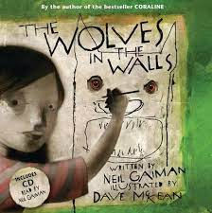
Year 5/6
Learning Highlights from Autumn 22
Wolves in the Walls
We returned to school after the Summer Break by reading Wolves in The Walls by Neil Gaiman. It is a funny picture book that tells the story of Lucy, a girl who has been forced out of her home by a pack of wolves who emerged from the walls. We researched wolves and wrote a report about them. We also wrote a letter to Lucy, suggesting how she could rid herself of her problem.
DT
Wolves in the Walls was also the stimulus for a DT topic – to design and make a moving toy. We learned how a cam can be used to transfer rotational movement into vertical movement and used this knowledge to design a toy where a wolf jumps out and then hides. We practised using a saw and a drill and then used these tools to construct our own toys. We learned how to draw an exploded diagram and then evaluated our finished toy against the original design.
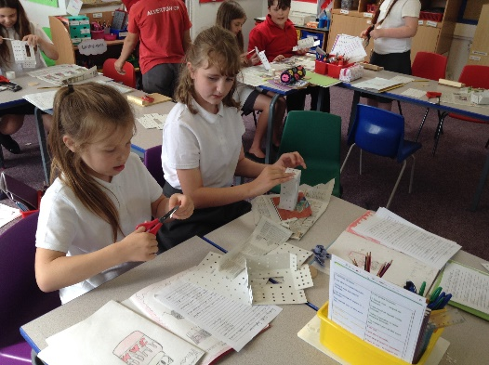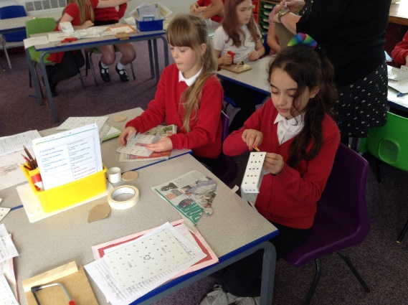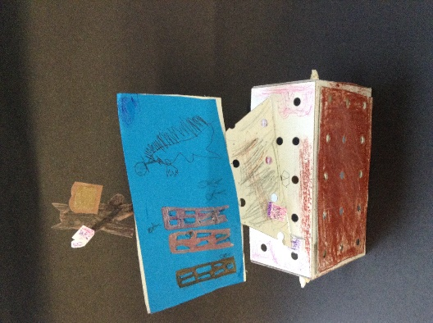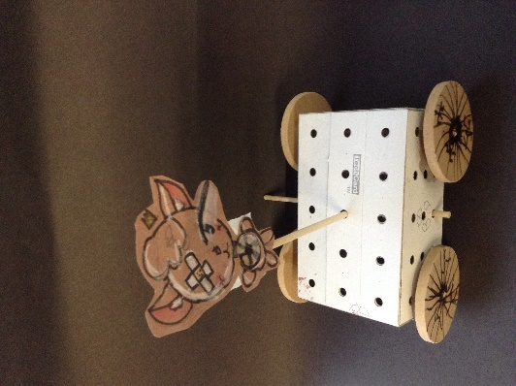

The Nowhere Emporium
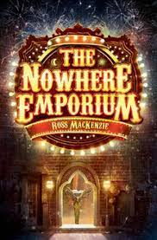
This half term, our learning has been led by The Nowhere Emporium by Ross McKenzie. It is an exciting book that is set in a magical world inside a very special shop. The story contains flashbacks and unfolds in an unpredictable and unexpected way. We have written descriptions of the Emporium and some of the main characters.
Science
In science, we have been learning about how a person changes throughout their life. We compared babies and toddlers. We also researched the changes that occur in puberty and in old age. It has been a very interesting topic and we wrote reports to demonstrate our learning.

Maths
Our focus in Maths has been place value, addition and subtraction. We have developed our understanding and improved our ability at problem solving.
Geography
In Geography, we have learned the names of the different countries and their capital cities. We located the different deserts and compared Antarctica and the Kalahari.
PE
We have been learning how to play Tag Rugby. We sent two teams to a Tag Rugby competition where we won some medals. Year 6 children have been improving their swimming. Year 5 children have been developing their gymnastics skills.
Music
We are learning to play the recorder.

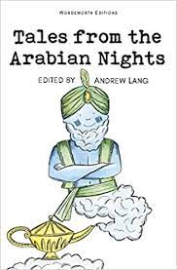
Autumn 2
The learning in the second part of the half term is led by Tales from the Arabian Nights.
History
We will be learning about the Persian Dynasty and life in 9th Century Baghdad.
Art
After researching traditional Arabic art we will be designing and making a geometric printing block that will be used to create beautiful repeating patterns.

Key Class Reminders
- Year of Writing
- PE next half term will be on a Thursday. Year 6 children are swimming on either Monday or Wednesday. Year 5 children have an extra PE session on Mondays.
- Homework is given out every Wednesday and always contains spellings to practise.
- Everyone in our class has logins to Mathletics and Times Table Rock Stars. Work is regularly set on Mathletics that links to the learning that we have been doing in class. There are also games to play that will improve mental maths skills. Children can also log on to Purplemash which supports all areas of the curriculum.

